COMP5310 – Principles of Data Science
Project Stage 1 — Explore, Clean, Summarize and Analyze
Dataset A: NSW Train Occupancy

Field | Details
Group Number | Lab014_Group_04
SID | 560457821
UniKey | rsel0893
Submission Date | 5 April 2026
Unit | COMP5310 – Principles of Data Science
University | The University of Sydney

Dataset A: NSW Train Occupancy

Step 1. Problem Definition

1.1 Business Problem
The NSW train network provides services to hundreds of thousands of passengers on a daily basis, yet a real-time insight about crowding in trains remains a challenge for both the operators and the passengers alike. This analysis defines the following classification problem:

"Is it possible to predict a train’s occupancy status based on features such as route direction, station sequence number, service line and time of day?”

1.2 Stakeholders and Benefits

Stakeholder | Benefit from Solving the Problem
Transport for NSW | Optimize train scheduling so that additional services can be deployed during peak hours.
Commuters | Will be able to plan less crowded journeys and save time.
City Planners | Understand peak demand patterns to improve infrastructure decisions.
Station Managers | Proactively manage platform services to avoid crowding and support good passenger flow.

1.3 Problem Type
This problem statement can be modelled as a classification problem. The target variable being Occupancy Status, a categorical variable with three classes: MANY_SEATS_AVAILABLE, FEW_SEATS_AVAILABLE, and STANDING_ROOM_ONLY. The goal is to predict which category a given train service falls into based on its route, direction, and temporal features.

Step 2. Data Description

2.1 Dataset Overview
The NSW Train Occupancy dataset was loaded and inspected to understand its structure and content before any cleaning was applied to the dataset.

Property | Value
Total Rows (instances) | 50,250
Total Columns (attributes) | 14
Missing Values | Present (dropped during cleaning)
Duplicate Rows | Present (removed during cleaning)

2.2 Data Types of Each Attribute
Attribute | Data Type | Description
day | int64 | Calendar day of the recorded service
Node.Seq.Order | int64 | Station sequence position within the route
Occupancy Status | object (categorical) | Crowding level: MANY_SEATS_AVAILABLE, FEW_SEATS_AVAILABLE, STANDING_ROOM_ONLY
Segment.Direction | object (categorical) | Direction of travel: Up or Down
Service.Line | object (categorical) | Name of the train service line
Other columns | object / int64 | Station names, origin/destination, train type, service identifiers.

2.3 Missing Values and Duplicates
An initial inspection using df.isnull().sum() and df.duplicated().sum() revealed the presence of both missing values and duplicate rows. The exact counts are detailed below:

Issue | Finding | Action Taken
Missing Values | Present across multiple columns | Rows with missing values dropped using df.dropna()
Duplicate Rows | Duplicate entries detected | Removed using df.drop_duplicates()
Rows after Cleaning | Reduced from 50,250 | Final shape verified after cleaning

2.4 Unique Values in Categorical Features
Key categorical columns were inspected for unique values. This revealed data quality issues that are addressed in Step 3:
- Occupancy Status: Initially showed inconsistent entries including 'MANY_SEATSAVAILABLE' (missing underscore) and 'VTANDING_ROOM_ONLY' (typographical error).
- Segment.Direction: When analyzed it was found that it had 4 unique values in the raw data when in reality only 2 directions existed in the dataset. Turned out the issue was caused due to trailing whitespaces in (“Up” and “Down”).
- Service.Line: Multiple train service lines are present across the NSW train network.

Step 3. Data Cleaning and Processing

3.1 Issues Identified and Cleaning Strategies
The following data quality issues were identified and resolved using data cleaning strategies.
“Some issues (in Occupancy Status & Segment.Direction) were discovered iteratively during EDA and fixed retroactively, as noted in the notebook.”

Issue | Column Affected | Cleaning Strategy | Justification
Missing values | Multiple columns | Dropped rows using df.dropna() | Rows with missing values cannot be reliably imputed with values without domain knowledge. Removal of such rows ensures data integrity.
Duplicate rows | Entire dataset | Removed using df.drop_duplicates() | Duplicates would skew frequency counts and introduce bias in EDA and modelling.
Inconsistent capitalization | Occupancy Status | Standardised to uppercase using str.upper() | Ensures consistent category labels for grouping and visualization.
Missing underscore typo | Occupancy Status ('MANY_SEATSAVAILABLE') | Replaced using df.replace() | Corrects the label to match the valid category MANY_SEATS_AVAILABLE
Typographical error | Occupancy Status ('VTANDING_ROOM_ONLY') | Replaced using df.replace() | Corrects the label to match the valid category STANDING_ROOM_ONLY
Trailing whitespace | Segment.Direction | Stripped using str.strip() | Trailing spaces caused Up and Down to appear as 4 distinct categories instead of 2.

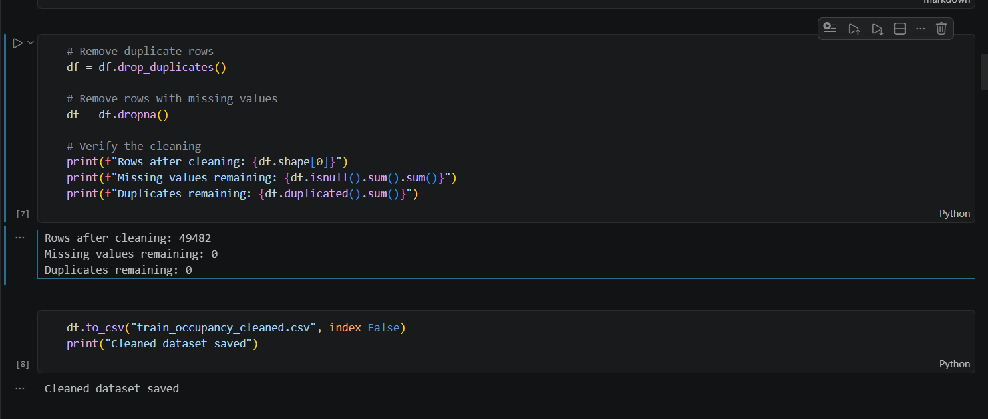
Figure 1: Missing values and duplicate rows removed using appropriate functions.

Insight on missing and duplicate values: Upon thorough inspection of the dataset, the total missing values and duplicate rows were calculated to be 522 and 250.

This implies approximately 49,478 rows are expected after cleaning. However, the actual count came out to 49,482 rows, suggesting some rows had both missing values and duplicates simultaneously.

3.2 Data After Cleaning
After applying all cleaning processes, the dataset was verified and saved as train_occupancy_cleaned.csv. The final cleaned dataset had no missing values, no duplicate rows, and ready for EDA and future modelling in Stage 2. However, note: some issues were discovered during EDA (please refer to section 3.1 for more information).

Step 4. Exploratory Data Analysis
Four features were selected for EDA, two categorical attributes (Occupancy Status, Segment.Direction) and two numerical attributes (Node.Seq.Order, day). These were chosen because of their direct relevance to the research question defined in Step 1.

NOTE: Initially Service.Line attribute was considered for categorical feature 2, but due to the presence of a huge spectrum of unique categorical values for the attribute, Segment.Direction seemed to be a better option than Service.Line attribute since it only had 2 unique values upon cleaning of the trailing whitespaces in its values.

4.1 Categorical Feature 1: Occupancy Status
A bar chart was used to visualize the distribution of occupancy categories, as bar charts are the standard method for comparing frequencies across distinct categorical groups.

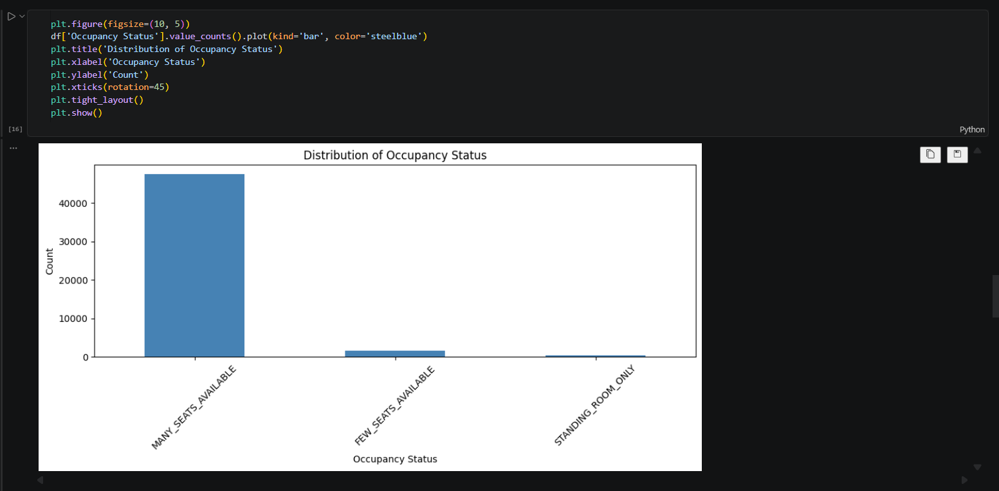
Figure 2: Occupancy Status bar plot against Count

The chart reveals a heavily imbalanced distribution:
- MANY_SEATS_AVAILABLE: ~47,500 services, is the dominant category by a large margin
- FEW_SEATS_AVAILABLE: ~1,581 services, significantly less common
- STANDING_ROOM_ONLY: ~396 services, extremely rare

Insight: NSW trains are overwhelmingly uncrowded. The majority of services have many seats available, indicating that the network is not operating near capacity for most of the day. This class imbalance will be addressed during the Stage 2 modelling.

4.2 Categorical Feature 2 — Segment Direction
A bar chart was used to compare the number of services in each direction of travel since the values were discrete, bar charts make the most suitable option for visualization here.

After removing trailing whitespace, exactly two categories were confirmed:
- Up direction: ~24,939 services
- Down direction: ~24,543 services

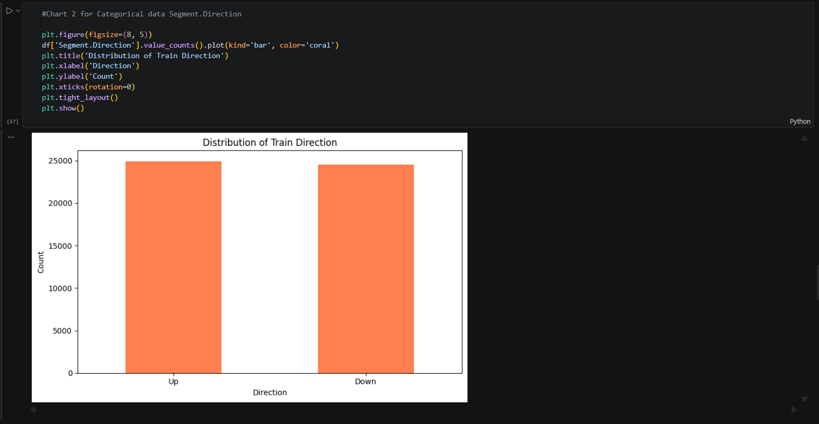

Figure 3: Segment Direction attribute bar graph plotted against Count

Insight: Train services are almost perfectly balanced between Up and Down directions. This is consistent with expectations for a rail network, that is: for every service in one direction, there is a corresponding return service. This balance also indicates that there are no directional biases in the data.

4.3 Numerical Feature 1: Node Sequence Order
A histogram was used to visualize the distribution of Node.Seq.Order, which represents the position of a station within a route (stop 1 being the first stop, stop 35 being the last on the longest routes).

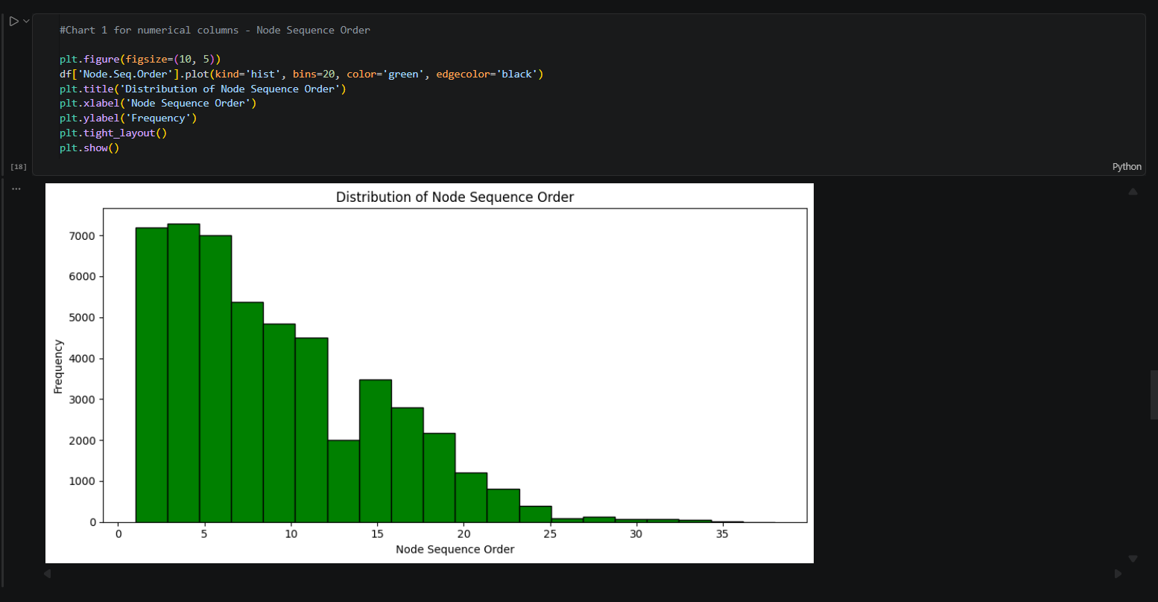
Figure 4: Distribution of Node Sequence Order — frequency of observations per stop position
- Stop 1 has the highest frequency, every route starts here, so all services contribute a record at stop 1.
- Frequency decreases as stop number increases, only longer routes reach higher stop numbers.
- Very few observations exist beyond stop 15, indicating that most NSW train routes have fewer than 15 stops.

Insight: Most train services in NSW have fewer than 15 stops, with stop position frequency decreasing as sequence order increases, suggesting that longer routes are less common in the train network. This feature is relevant to the research question as occupancy may increase along a route as passengers board.

4.4 Numerical Feature 2: Day

Carried out process: Initially a histogram was used to visualize the train services assuming that the day attribute in the dataset represented days of the week instead of calendar dates over the span of 8 days from day 9 to day 16.

Hence, a bar chart was used to visualize the number of train services recorded per calendar day, providing a clearer view than a histogram given the discrete nature of the day values.

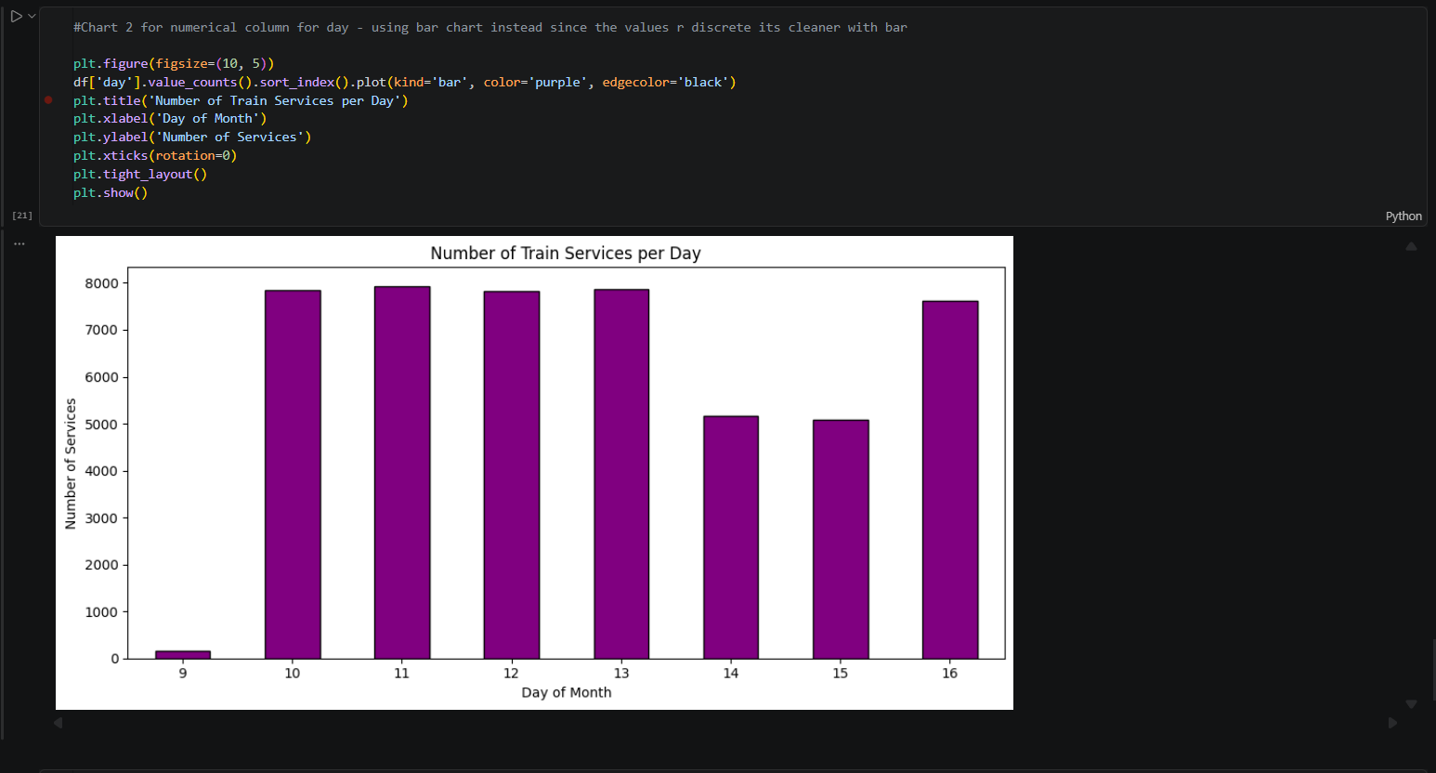
Figure 5: Number of train services recorded per calendar day (days 9–16)

- Day 9: Very few services were recorded assuming the data collection had just started.
- Days 10–13: Consistently ~8,000 services each weekday operations were observed.
- Day 14: ~5,000 services, consistent with a Saturday (fewer commuter services).
- Days 15–16: Combined ~12,500 services covering Sunday and the return to Monday.

Insight: The day column represents calendar dates rather than day-of-week numbers. The dataset spans 8 days of train service records. Weekday services (days 10 to 13, 16) averaged approximately 7,900 train services per day, while weekend services (days 14 to 15) averaged only 5,100, implying about 35% fewer services on weekends, reflecting lower commuter demand.

4.5 Correlation Between Numerical Features
A correlation matrix was computed between the two numerical features: day and Node.Seq.Order, to assess any linear relationship between them.

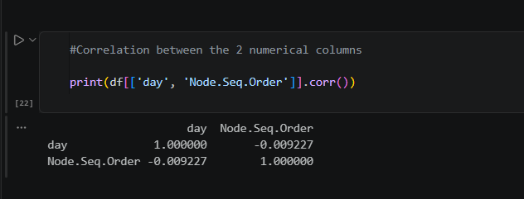
Figure 6: Correlation matrix between day and Node.Seq.Order

Feature Pair | Pearson Correlation | Interpretation
day vs Node.Seq.Order | -0.009 | Virtually no linear relationship
day vs day | 1.000 | Perfect self-correlation (expected)
Node.Seq.Order vs Node.Seq.Order | 1.000 | Perfect self-correlation (expected)

Insight: The correlation between day and Node.Seq.Order is -0.009, indicating virtually no linear relationship between the calendar day and station sequence order. This is expected as the route structure of a train does not change based on the calendar day. These two features are therefore independent and can both be used as input features in Stage 2 modelling without multicollinearity concerns.

4.6 Summary of EDA Findings
Feature | Type | Key Finding
Occupancy Status | Categorical | Heavily imbalanced: approximately 95%+ of services have many seats available, crowding is rare.
Segment.Direction | Categorical | Perfectly balanced between Up and Down, no directional bias was seen in the dataset.
Node.Seq.Order | Numerical | Most routes have fewer than 15 stops; longer routes are less common which is to be expected.
day | Numerical | Weekdays have ~35% more services than weekends, according to the dataset record span of 8 days.
day vs Node.Seq.Order | Correlation | Correlation of -0.009, features are independent; no multicollinearity concerns for stage 2 modelling.

AI ACKNOWLEDGMENT

I used Claude (Anthropic) from 28–31 March 2026 to assist with structuring the report layout and understanding how to phrase data insights. All code; data analysis, visualizations, cleaning decisions, and final written content are my own. I reviewed, paraphrased, and validated all AI-suggested content before inclusion in this report.

Tool used: Claude (Anthropic)

Dates used: 28–31 March 2026

How it was used: Assisted with report structure and rephrasing of insights.
My own contribution: All analysis, data cleaning, code, visualizations, and final conclusions are my own.

